Job Pack: Production Manager
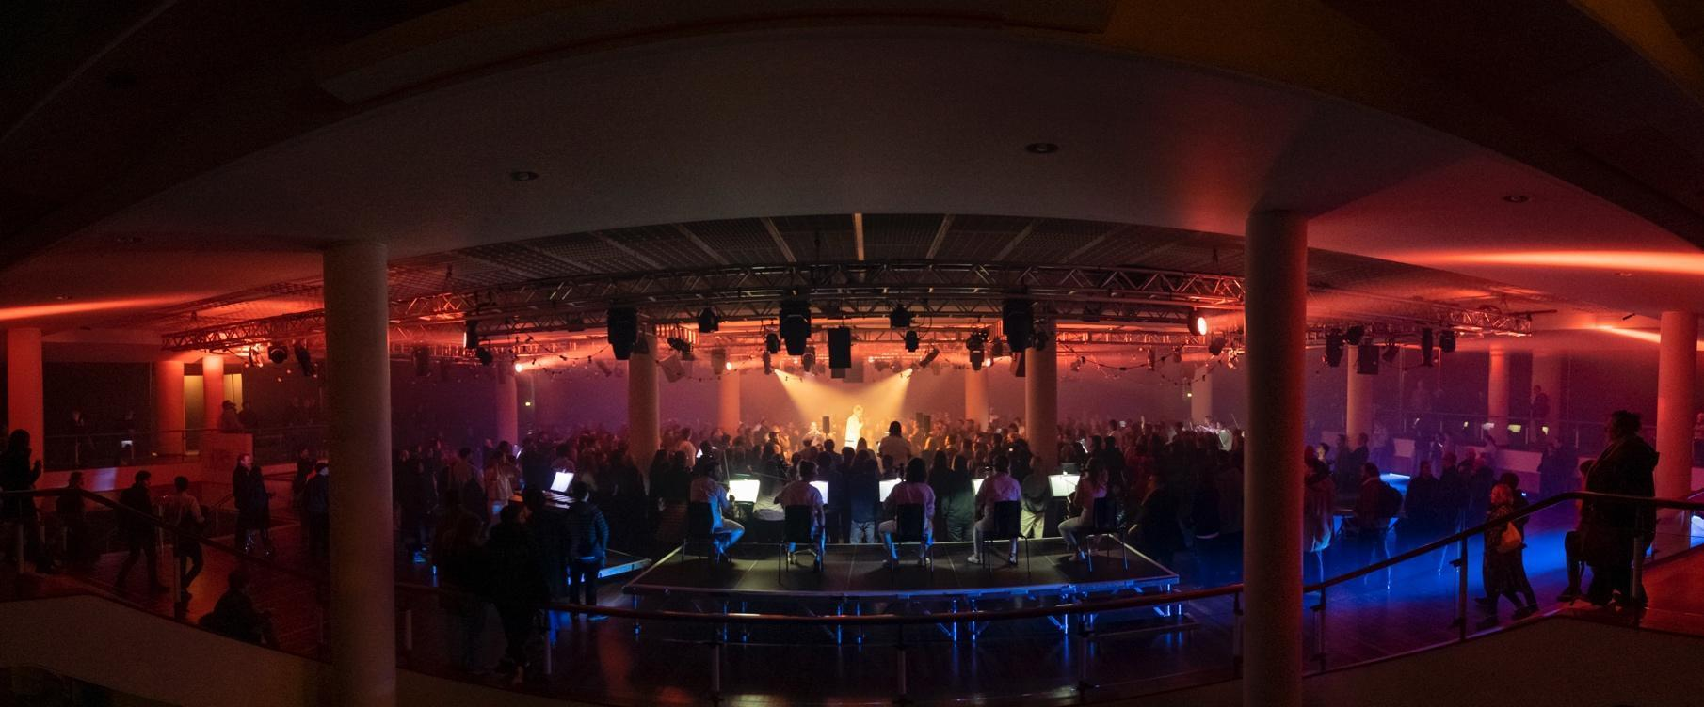
Thank you for your interest in working with Paraorchestra. This is an extraordinary moment to join our team following a rapid expansion of our programmes, projects, partners, funders and team.

Paraorchestra creates award-winning, high quality and innovative orchestral work presented as large-scale live concerts, shows and tours, recordings and broadcast programmes. Attending a Paraorchestra show offers a transformational and emotive experience. Our artistic ethos brings audiences up close and personal with the musicians and artists, immersing them in the experience and shattering traditional preconceptions of what an orchestra does, where you might encounter it, what it plays, and who performs. Because of this approach, we attract a predominantly new, younger, and more diverse audience.

“Buzzing from an immersive music/dance piece where the audience is able to wander about on stage brushing up against singers, strings, bass, percussion, dancers. Music up so close you feel the vibrations.”
Kirsty Lang, broadcaster,
The Nature of Why at Southbank Centre, London

We are as adept performing in concert halls, as we are in theatres, galleries, outdoor music festivals, beachfronts, and housing estates. Our touring has reached across England, Scotland and Wales. We work most closely with Bristol Beacon, where Paraorchestra is Associate Artists at one of the UK’s most prominent, forward-thinking, concert venues and regularly perform at London’s Southbank Centre.

Our repertoire mixes new commissions with the contemporary and traditional; Steve Reich, Górecki and Mozart, as well as re-imagined work based on the music of Kate Bush, David Bowie, and Kraftwerk.

Across our programme of concerts and events, we offer a vision of the inclusive change that we want to see in the world. Professional disabled musicians, composers, and artists are the backbone of our creative output with 60% of our professional ensemble having lived experience of disability.

“The orchestra can include everyone, and it can be for everyone.”
Charles Hazlewood, Artistic Director, Paraorchestra

Our new artist development programme Modulate, is creating change at a structural level within the classical sector, offering opportunities for disabled musicians and composers to explore their practice in multiple bespoke ways. The programme goes beyond notions of levelling the playing field and is creating an environment in which disabled music creators can truly thrive.

Perhaps the best way to get a feel for what we do is via this short film:

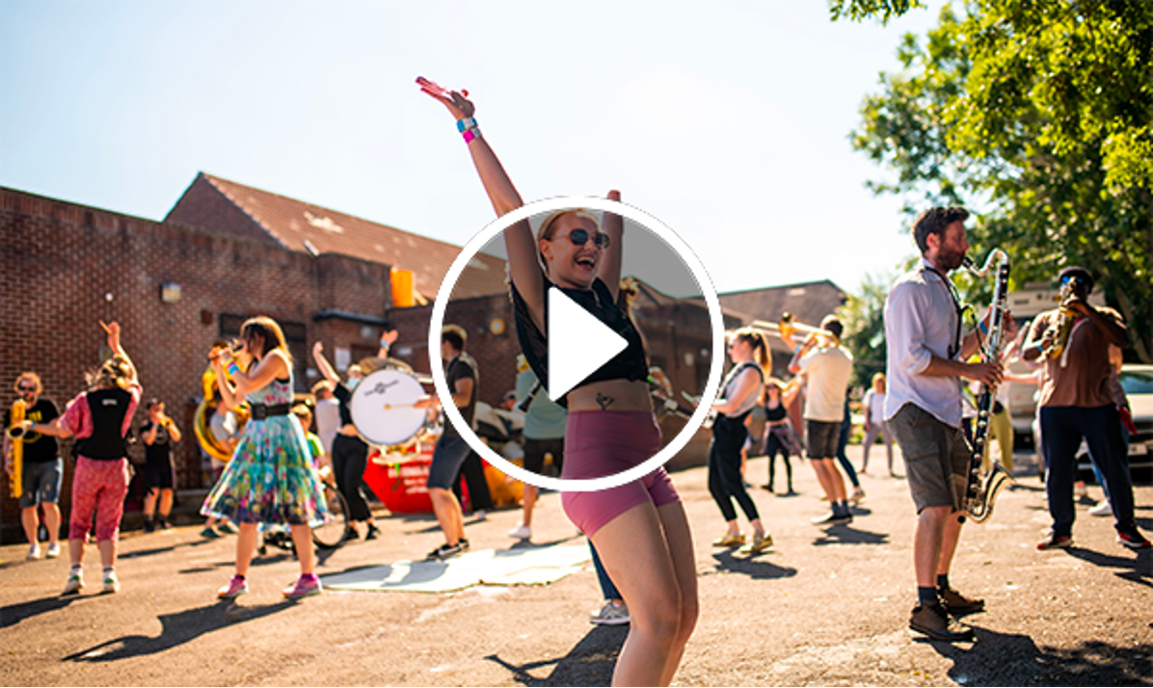
Click here for an audio-described version of the film

Here are some further examples of our work:

The Virtuous Circle (2024), a BBC Co-commission for the Bristol Proms reimagining the orchestral format as an immersive experience with Mozart’s 40th symphony at its core as well as a team of professional dancers and new compositions by Ivor Novello award-winner and Paraorchestra member Oliver Vibrans.

Trip The Light Fantastic (2023), a three-way collaboration between Paraorchestra, Bristol-based electronic composer Surgeons Girl and AV specialists Limbic Cinema commissioned by Bristol Beacon to celebrate the reopening of the venue after its once-in-a-generation transformation.

SMOOSH! (2021), a large-scale outdoor site-specific promenade performance of up to 70 professional and local musicians and dancers that is typically performed in and in co-creation with communities who do not traditionally attend concert halls.

Two TV projects: Beethoven and Me (2021), watched by 146,000 people, and which won Best Music Programme at the 2022 Broadcast Awards and Re-Inventing the Orchestra (2022), an unprecedented six-part documentary series, watched by 233,000 people.

The Unfolding (2022) our debut album, a collaboration with composer Hannah Peel released worldwide by Real World Records reached Number 1 in the Classical Album Charts and toured to Bristol, Gateshead, Edinburgh, London culminating in a headline performance at the Bluedot Festival near Manchester.

The Anatomy of the Orchestra, our sound installation for 65 musicians allows audiences to wander the orchestra up close and personal, continues to be in demand and was presented at the opening of the redeveloped Birmingham Symphony Hall in Summer 2021, and at Southbank Centre Summer 2022. A new iteration, Drone Refractions, premiered at Bristol Beacon and Southbank Centre in January 2024.

How we work
We are a passionate and openhearted team of people who are excited by the art we create and driven by the changes and opportunities we are initiating.

We take a person-centred approach when creating each of our projects, consulting with every musician or creative involved to ensure we remove any barriers that might prevent them performing at the highest level. Our collaborations with artists across genres and artforms, together with our ensembles of disabled and non-disabled musicians, are deepening levels of understanding, and encouraging an exciting and unique exchange of ideas and creative opportunities.

“I have felt so supported and welcomed during my start at Paraorchestra. It’s so lovely to be part of a team who treat each other with such kindness, trust and respect. Everyone was well prepared for my first day, the onboarding process has been faultless and I felt like part of the team straightaway.”
Holly Beasley-Garrigan, Artist Development Coordinator
(joined January 2024)
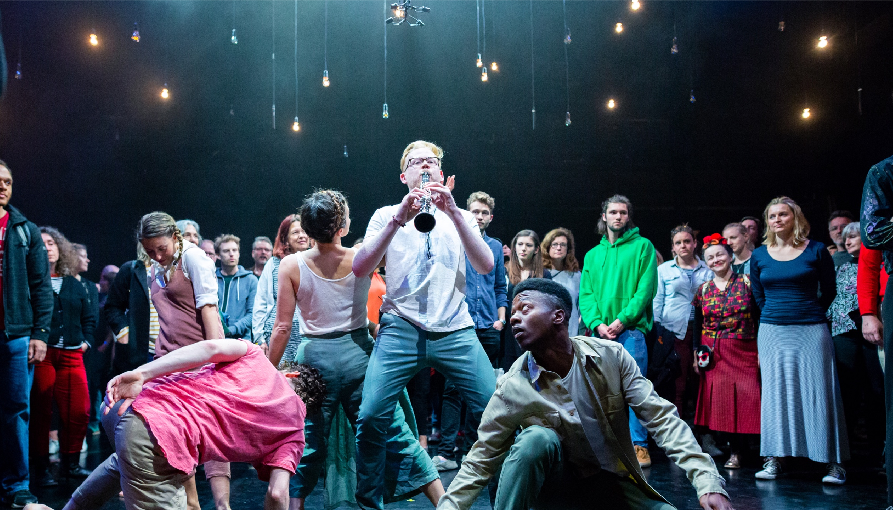
This whole ethos is extended throughout the team. We work collaboratively, with respect and consideration, nurturing a culture where no question is a ‘stupid question’ and everyone is equipped to enjoy, and take pride in, their work.

Access Support and Inclusivity
We believe all areas of our work will be stronger with greater diversity and welcome applications from those who bring difference.
We recognise that the arts have not been a go-to employer for anyone who identifies as disabled. We want to act positively and change this and would like to hear particularly from those that identify as D/deaf, disabled or neurodivergent under the Social Model of Disability or who have faced barriers to their career progressing due to access needs not being met.
If you are D/deaf, disabled or neurodivergent and you meet the essential criteria for the role, we will guarantee you an interview.
We are also able to support you with an application to Access to Work where appropriate. If you would like to discuss this before an application please email applications@paraorchestra.com and let us know how best to contact you.

“I joined Paraorchestra as Producer in 2023 and have loved every minute! The organisation has a wonderful approach to creating work in an ambitious and caring way, not sacrificing one for the other. And this applies to the way they look after their staff too, the systems and processes in place support a great work ethos of trust and collaboration. I have felt really well supported by my team and line manager. I have worked in the industry for 15 years and can honestly say I have never worked for such a caring (and efficient!) organisation.”
Ailie deBonnaire, Producer
(joined June 2023)

Applications

To apply, please send a CV and covering letter explaining how your experience, skills and personal attributes are right for the role to applications@paraorchestra.com

Please pay particular attention to the key responsibilities and the person specification, as matching these to your skills, experience and attributes is how we determine our shortlist for interviews.

Your covering letter can be a video or an audio file (no longer than 4 minutes) or written (no more than 2 sides of A4).

Please download and return a completed Equal Opportunities Survey along with your application.

If you need access support to complete and submit your application, please email applications@paraorchestra.com and let us know how best to contact you.

Here are some application Dos and Don’ts to bear in mind:
- DO include your phone number and contact details
- DO include dates on your work history
- DO tell us how you heard about the job
- DON’T include a photo or your date of birth – this is confidential data you don’t need to share with us
- DON’T forget to proofread for spelling and grammar errors

Interview Process and Key Dates

The deadline for applications is 12pm Monday 30 September 2024

Interviews will take place during the week commencing Monday 7 October 2024, date to be confirmed.

If your application is successfully shortlisted and you are invited to an interview, we will provide interview questions in advance, along with an organisational chart outlining all of the different roles in the organisation. Please be forthcoming with any access needs ahead of your interview so that we may accommodate them.

Interviews are likely to be held in person in Bristol, however, we are also happy to facilitate a Zoom interview with the panel if this works better for you. In certain situations we may decide to hold all interviews online using Zoom. If the interviews are held in person, we are happy to reimburse your travel expenses, and any additional access costs that you might have.

Feedback

If you are invited to interview but are unsuccessful we will provide feedback – on request – within two weeks of your interview. This may be verbal or written. We are unable to offer feedback on your initial application alone due to the high number of applications that we receive. If you have not heard from us within three weeks of the deadline, you can assume that on this occasion you have been unsuccessful.

Questions?

If you have any questions about the recruitment process, or would like to understand more about our culture, we can arrange an informal chat with one of the newest members of the team about their experiences to date and what it’s like to work for Paraorchestra.

Please get in touch on applications@paraorchestra.com. This is an opportunity for you to learn more about how we work, rather than the specifics of the role advertised, and you will not be talking to a member of the interviewing panel.

Thanks again for your interest in the role and we look forward to reading your application.
Warm wishes,

Jonathan Harper
Chief Executive Officer
Paraorchestra

Position: Production Manager

Reports to: Senior Producer (Projects)
Salary: £38,000 pro rata (0.6 / 3 days)

Working pattern: This is a flexible role where the nature of the work dictates that some weeks will be quieter and others very busy - usually correlating to when we are on site and on tour.
As a PAYE contract, you will be paid evenly in monthly salary instalments for the equivalent of 24 hours weekly, and have access to our range of enhanced employee benefits.
However, we would expect that you would work closely with the Senior Producer to map out how many hours are needed to be worked weekly according to production needs, with a view to ensuring that you accrue enough hours to cover forthcoming on site and touring needs. Occasionally for longer touring periods we would agree in advance the payment of additional hours at your PAYE rate.
As this is a part time role we are very open to discussing how this may fit around other work commitments, and we would expect to be flexible about this.
If you would like to discuss this further before you put in an application please email applications@paraorchestra.com to arrange an informal conversation.

Contract type: PAYE
We believe offering this role as a PAYE role offers the best option to individuals in terms of additional and enhanced benefits that we are able to offer, and in terms of continuity and commitment on both sides. However, we are open to discussing this role as a freelance position and so please let us know in your cover letter if this would be your preference.

Please see the Summary Terms and Conditions at the end of the document for further information about our flexible approach to working hours and location, how you can propose a variation to the advertised terms, the benefits that we offer our employees, and other key elements of our contracts.

Role purpose
The Production Manager is a critical role within the producing team, with responsibility for overseeing the planning and delivery of the technical production of all Paraorchestra projects.
This will include feeding into the project creation process, advancing performances and tours with venues and external organisations and managing all aspects of project production on site.
The production manager will also support Modulate, our artist development programme.

Key responsibilities
- Lead on production on the ground, including during get-in, rehearsals, performances and get-out.
- Coordinate technical teams on the ground during projects, such as sound, lighting, local crew.
- Oversee all production aspects of new ambitious projects, from conception and budgeting through to successful delivery.
- Ensure the highest possible technical standards are achieved within the allocated resources for all Paraorchestra work including projects and the artist development programme.
- Create and update technical specs for new and existing projects, suitable for sharing internally and with external venues and partners.
- Work closely and maintain positive working relationships with multiple stakeholders involved in projects including Paraorchestra staff, freelancers, venue/partner teams, external hire companies, audio engineers, lighting designers, AV technicians, stage managers, designers, and choreographers.
- Work closely with the producing team to ensure production budgets are created, planned, managed, and reconciled accurately.
- Lead the recruitment and management of additional freelance technical staff where required.
- Source and book suitable production equipment, manage all technical hires and build up a trusted list of suppliers.
- Produce and implement production schedules for all Paraorchestra projects.
- Work with the Orchestra Manager to create stage plans.
- Organise van hire and drive vans or arrange a suitable alternative when required.
- Create and manage all health and safety documentation for Paraorchestra projects, including risk assessments for all projects.
- Attend regular internal project meetings as well as other meetings as and when required.
- Attend weekly team meetings and training as required as part of your role.
- Remain current with industry best practice and applicable technologies.
- Feed into Paraorchestra’s post-project evaluation process.
- Take an active role in supporting Paraorchestra’s aim to reduce its carbon footprint annually, working with colleagues to deliver the Carbon Footprint Reduction action plan which impacts on delivery of projects across travel, catering, accommodation and production.
- Comply with all Paraorchestra policies including Equal Opportunities, Environmental and Safeguarding policies.

This list of responsibilities is not exhaustive, and the Production Manager may be required to perform duties outside of this as operationally required and at the discretion of the Senior Producer (Projects).

Person specification

Essential experience, skills and knowledge:

- At least 5 years’ production management experience working on mid or large scale projects in either the music or arts sector, from early stage through to realisation and implementation
- Experience working across multiple art forms.
- Experience in production managing performances taking place not only in venues but within festivals and outdoor environments.
- Excellent knowledge (theory and practice) of Health & Safety legislation and regulations, requirements, and guidance.
- Experience producing stage plans preferably in CAD or Vectorworks.
- A strong technical background particularly in sound and lighting.
- Exceptional financial management experience relating to large-scale artistic work and proven experience of holding a production budget from start to finish.
- Experience producing production and technical riders.
- Excellent communication, teamwork, and interpersonal skills, with the ability to communicate effectively with venue and event staff as well as the general public, audiences, and participants.
- Excellent time management and multi-tasking skills with the ability work calmly under pressure, to tight schedules and on multiple projects simultaneously.
- A valid UK driving licence.
- Ability to work flexibly and manage your working pattern with excellent open communication to line management and other colleagues
Desirable experience, skills and knowledge:
- Experience working on contemporary music performances
- Experience of touring in the UK and internationally.
- Previous experience working with disabled artists and an understanding of the social model of disability.
- Experience driving large vehicles (LWB transit and Luton vans).

Summary of main terms & conditions and working conditions

Working conditions

Paraorchestra seeks to offer a working environment that is flexible and responds to a wide range of employee needs.

You will see our approach to this laid out below. We will always need to balance this with our mission as an artistic organisation, to create and tour large scale work in the UK and internationally. Requests for flexibility will be considered alongside Paraorchestra’s need for employees to fulfil the function of their roles, which means that on occasion, we will not be able to agree to all requests for flexible working.

Employees requesting reasonable adjustments for access needs will be discussed and dealt with separately to the flexible working process.

Hours

This is a flexible role where the nature of the work dictates that some weeks will be quieter and others very busy - usually correlating to when we are on site and on tour.
On a PAYE contract, you will be paid evenly in monthly salary instalments for the equivalent of 24 hours weekly, and have access to our full range of enhanced employee benefits.
However, we would expect that you would work closely with the Senior Producer to map out how many hours are needed to be worked weekly according to advancing production needs, with a view to ensuring that you accrue enough hours to cover forthcoming on-site and touring needs.
Occasionally for longer touring periods we would agree in advance the payment of additional hours at your PAYE rate.

We will look forward to discussing how this has worked in the past with previous Production Managers, and how the hours can be managed in conjunction with any other commitments that you might have.

We are looking for a flexible and dynamic individual able to communicate openly and clearly about managing this type of working pattern.

If you would like to talk through the working pattern for this role in advance of applying, please email us on applications@paraorchestra.com to arrange an informal conversation.

Location

Our preference is for you to be based in Bristol or the South West and to have a regular office presence when not working on site or on tour.
Paraorchestra offers hybrid working for all employees. This means that it may be possible for you to work remotely from time to time and/or not be based in Bristol or the South West. Please be forthcoming in your application to us if you are not planning to be Bristol or South West based, and/or if you propose working in a mainly remote capacity.

Touring

While we aim to make as much of our work as possible in Bristol we are an organisation that has a touring remit and this role is crucial when Paraorchestra is touring its work. There is an expectation that to deliver this role you would need to be comfortable with some national and international travel each year. The amount of time required will vary each year but as an example:

UK travel

Our busy periods are typically in the Spring (March to May) & Autumn (Sept to November). During this time we would typically expect touring work to involve travel away from Bristol for between 2-7 nights at a time, every couple of months. Performances do fall outside this period and touring dates are given with as much notice as possible.

International travel

From 2025 we aim to average 1-2 international projects a year where you may be abroad for 5-14 days at a time. There is always a long lead in time to our international work and we are open to discussing how we make this work for the post holder.

Main terms & conditions

Contract
This is a permanent, part time, PAYE contract, subject to a six month probation period.

Salary
£38,000 (pro rata for 3 days/0.6)

Annual Leave
25 days Annual Leave plus UK statutory bank holidays (pro rata for 3 days)
Notice Period
Following successful completion of the probationary period, the period of notice will be 3 months on either side.

Pension
Paraorchestra operates a NEST stakeholder pension scheme, where the employer contributes 4% and employee contributes 5% of your salary annually.
Other Benefits
Paraorchestra offers enhanced paid leave (following qualifying periods) across Sickness Leave, Parental and Dependents Leave, Maternity and Adoption Paid Leave, Paternity Leave and Bereavement Leave. The details are as follows:
Sickness
6 weeks on full pay, with an additional Exceptional Circumstances clause offering 12 weeks on full pay followed by 12 weeks on half pay.

Maternity/Adoption
12 weeks on full pay followed by 12 weeks on half pay, and statutory thereafter.
Paternity
3 weeks of paid leave which can be taken as a block or separately, on full pay.

Time off to care for dependents
A supportive environment for its employees with dependents, with 5 days paid leave available.

Bereavement
4 weeks on full pay in the event of bereavement of a child under 18 years of age or a spouse or partner, and 2 days in the event of a close relative.

